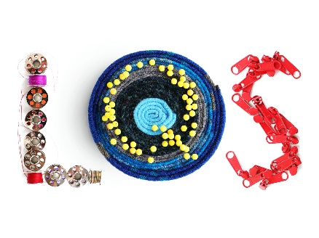

«Newspaper/Publication name to whom you are sending the release»
FOR RELEASE ANY TIME BETWEEN JANUARY 28 AND FEBRUARY 28, 2023

Contact: <<contact name>>
Phone: <<contact phone>>
Email: <<contact email>>

«Shop name» <<Headline for Publication to use.>>
Local quilt shop, «Shop_name», is competing this year in the 6th Annual Local Quilt Shop Contest hosted by ByAnnie.

«city», «state», <<date>> - «Shop_name» needs your support as they once again compete in ByAnnie.com’s Local Quilt Shop Contest. This annual contest is dedicated to supporting local economies and the timeless tradition of sewing.

Each year sewists around the world vote for their favorite local quilt shops and share what makes them special.

<<<<<<something special about your shop, about your success last year, or upcoming events>>>>>>>>>>

They and all local quilt shops are counting on your support for a chance to win major prizes that can help «Shop_name» to thrive, as well as develop their reputation among the community.

Vote for your favorite shop in ByAnnie’s 6th Annual Local Quilt Shop Contest by using the following URL. Voting is open from January 28nd - February 28th, 2023.
Voting link: www.LQSContest.com/VOTE

Local Quilt Shops are the lifeblood of a community and are important because they offer classes, resources, and inspiration for millions of dedicated sewists.

According to recent data gathered*, there are 85 million people who actively engage in crafts and creative projects. They generate $35 billion in sales annually to stimulate economies and keep creativity alive. 10 to 12 million of these creatives are active quilters. According to polls, these quilters overwhelmingly prefer to shop at their local quilt shops.

*Data gathered by Premier Needle Arts 2019.
###

If you would like more information about this topic visit LQSContest.com, or please call «Shop_name» at «Shop_phone», or email «Shop_email».

